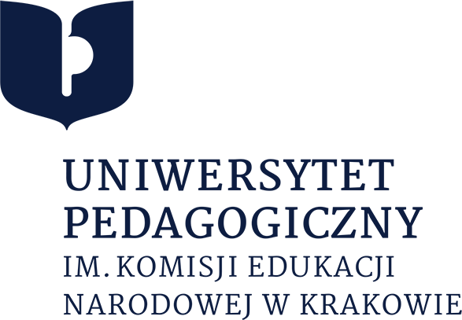

Pedagogical University of Kraków announces an open call for a PhD scholarship as part of a National Science Centre of Poland OPUS 23 project „A comprehensive approach to powders for pharmaceutical 3D printing using Selective Laser Sintering - development of strategies for excipient matching towards desired functional properties”
(PI: Dr hab. inż. Piotr Kulinowski, prof. UP)

The successful candidate will receive a monthly stipend of 5000 PLN (gross) starting from 1 September 2023. There will be the possibility of starting later, i.e. (1 November 2023), if justified reasonably.

It is expected that the PhD student will conduct research on the topic of the grant, participate in meetings of the research group and international conferences, and pursuit a doctoral degree by writing a dissertation (not necessarily related to the grant topic) and fulfilling all the other requirements of the PUK Doctoral School.

Details of the project: https://projekty.ncn.gov.pl/index.php?projekt_id=554911
For a full description and in case of questions, please contact the PI.

Responsibilities: Contribution to the project includes computer-aided design of dosage forms; Selecting/tuning parameters for Selective Laser Sintering 3D printing of dosage forms; X-ray microtomography data analysis; participation in magnetic resonance imaging (MRI) experiments; MRI data analysis and interpretation; participation in NMR relaxometry experiments; relaxometry data analysis and interpretation; participation in the integration of results obtained using various methods; publications preparation; completing Ph.D. thesis. At the moment planned contribution is similar to Post-doc_1 due to the vast scope of work and unknown Post-doc_1 profile. It will be adjusted after recruiting Doktorant_1 and Postdoc_1. The same regarding the discipline and profile of a Ph.D. thesis.

Requirements: (1) M.Sc. in Material Science, Biomedical Engineering, Physics, Biophysics, Pharmacy, or related disciplines; (2) M.Sc. thesis should be based on experimental works. (3) The candidate should be willing to work in an interdisciplinary team in close collaboration with researchers from National Medicines Institute.

Submissions should include:
• cover letter (one page)
• CV, indicating the candidate’s Master’s degree defence date
• academic transcript(s)
• description of research interests and their connection to the project and future dissertation topic
• list of publications and academic talks (if applicable)
• Master’s thesis in the electronic format (if applicable)
• contact information for two references willing to submit recommendation letters.
Documents should be submitted as one compiled PDF file by the deadline of 18 August 2023 to the PI at piotr.kulinowski@up.krakow.pl.
Formal requirements and legal notes (in Polish) can be accessed at:
https://www.ncn.gov.pl/sites/default/files/pliki/uchwaly-rady/2019/uchwala25_2019-zal1.pdf

